How to Install Chrome Extension Applications
Copy the zip file to local folder and extract the zip file. The zip file contains 2 folders
- app
app folder is used to add extension to chrome browser

- ChromeExtItemATAPartNumber
ChromeExtItemATAPartNumber is deployed in IIS sever and is used to respond to the commands from chrome browser.
How to add extension to Chrome Browser
Open the Chrome browser
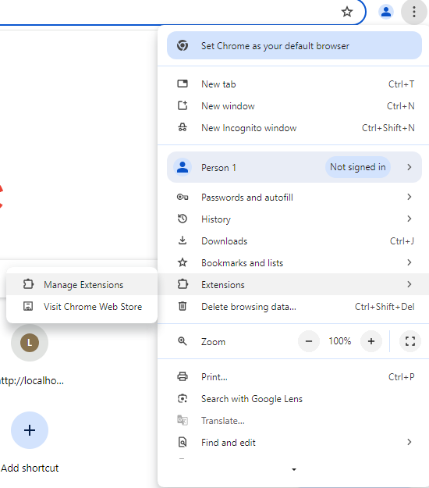
Click on Go to … -> Extensions -> Manage Extensions as shown below

Following dialog will be launched
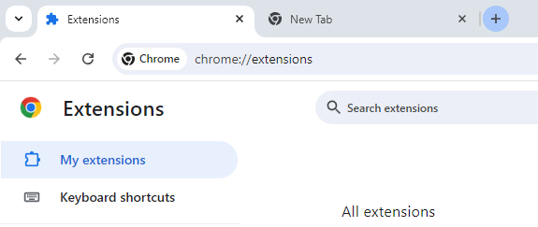

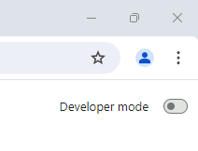
Switch on the Developer mode (If it is in off mode)

The following buttons will be shown in the chrome browser
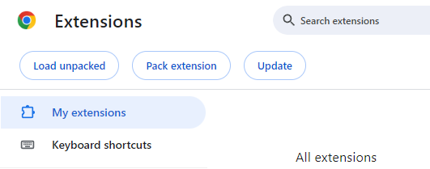
Click on “Load unpacked” button, a folder browse dialog will be opened. Select the app(downloaded) folder and click on Select Folder as shown below
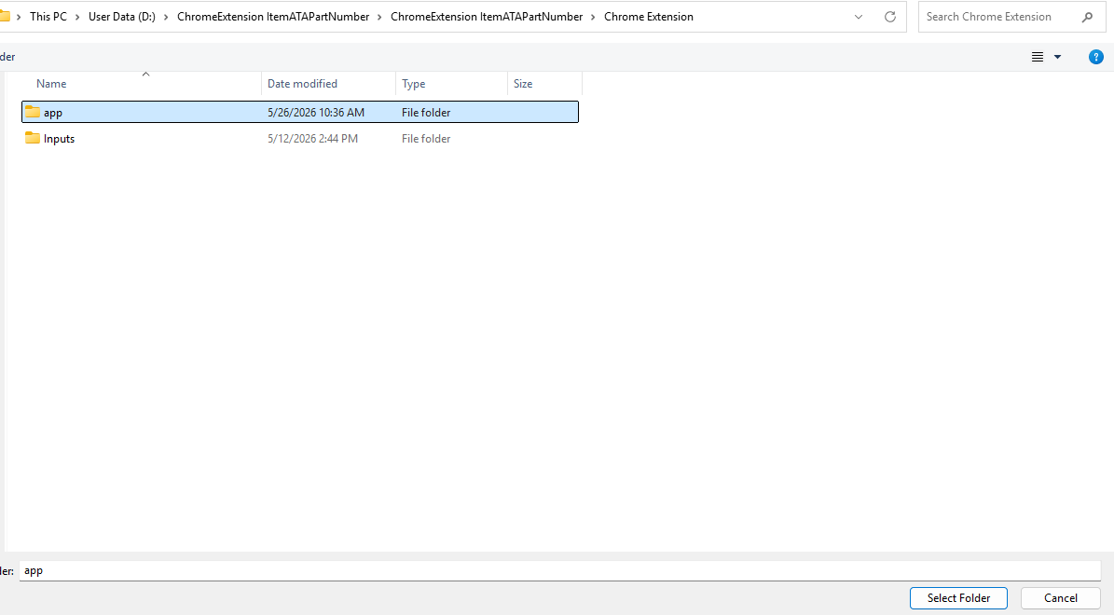
The extension will be added to chrome browser as shown below.
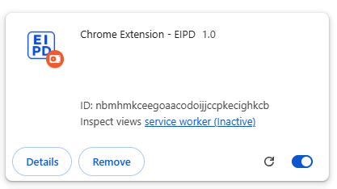

How Pin the extension to Chrome
Once extension is added, click on the below icon in the chrome
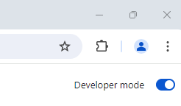

The following dialog will be opened
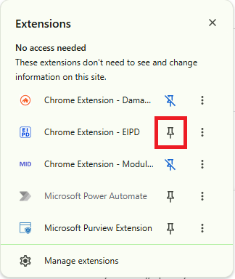
Click on pin icon. The Extension will get added to Chrome as shown below
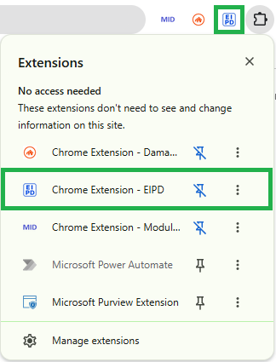

How to change Icon

In the app folder, update the “icon.png” with new icon and click on refresh as shown below in the extension. The new icon will be updated.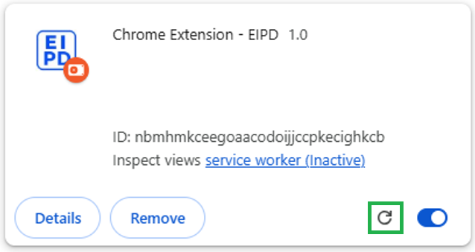

How Deploy “ChromeExtItemATAPartNumber” in IIS server
Copy the “ChromeExtItemATAPartNumber” folder in C:\inetpub\wwwroot folder
Note: If folder already exists, delete the existing folder and copy the new folder.
Open the IIS server (use search option)
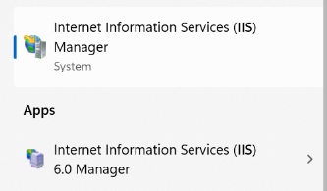
Once IIS is opened, go to Sites->Default Websites. User can see ChromeExtItemATAPartNumber folder. Select the folder, right click and click on “Add Application”
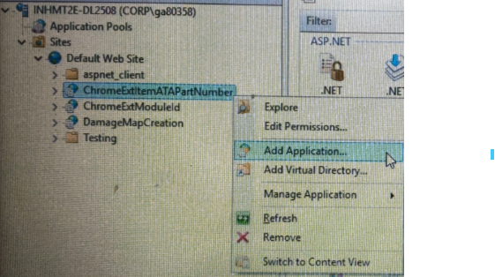
The application will be deployed at the local system.

How to update the excel paths
Go to C:\inetpub\wwwroot\ChromeExtItemATAPartNumber folder, open the “Web.config” file
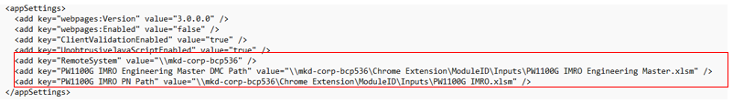
Update the
- RemoteSystem
- PW1100G IMRO Engineering Master DMC Path
- PW1100G IMRO PN Path
Paths in web config file and save the file

